1. Deploy this app to cloud (AWS EC2)
2. Create EC2 instance using amazon console, also in security group add a rule to allow HTTP incoming traffic
3. Create a key while creating instance and download it in your local.

It will be in .pem extension

For me it saved in C:\Users\KARTHIK\.ssh

1. You can check any youtube for help
2. <https://youtu.be/q8NOmLD5pTU?si=ae2Bhfx_9EaLeSAU>
3. Steps to execute in win command box:-

* $ ssh -i "C:\Users\KARTHIK\.ssh\bhp.pem" [ubuntu@ec2-13-201-228-246.ap-south-1.compute.amazonaws.com](mailto:ubuntu@ec2-13-201-228-246.ap-south-1.compute.amazonaws.com)
* sudo apt-get update
* sudo apt-get install nginx
* sudo service nginx status

Note:- I got status as failed – so the possibilities are that acpache2 is running, so you need to stop that first.

* sudo service nginx start

output:- ob for nginx.service failed because the control process exited with error code.

See "systemctl status nginx.service" and "journalctl -xeu nginx.service" for details.

* sudo journalctl -xeu nginx.service

Note:- I ll get logs here, it was all clear, so I checked if it is using port 80

* sudo netstat -tulnp | grep :80

note:- was checking if it is using post 80 or not

and this was the output i got:-

tcp6 0 0 :::80 :::* LISTEN 405/apache2

so here i can see apache2 is running, so i need to stop that first in order to start nginx

* less /var/log/nginx/error.log

Note:- here you can find the logs

* sudo service apache2 status

Note:- here I came to know, this was actively running, so I need to stop this

* sudo service apache2 stop
* sudo service apache2 status

Note:- Now it is stopped

* sudo apt-get install nginx
* sudo service nginx start
* sudo service nginx status

Note:- Now it is actively running

* sudo service nginx restart
* cd /etc/nginx/sites-available/
* ll
* sudo vim bhp.conf

Note:- in this bhp.conf -> write this

server {

listen 80;

server_name bhp;

root /home/ubuntu/ Project1/BloreHousePrediction/client;

index app.html;

location /api/ {

rewrite ^/api(.*) $1 break;

proxy_pass http://127.0.0.1:5000;

}

}

Then to save and close this,

:wq

[the above command ll save and close]

* cd /etc/nginx/sites-enabled/
* ll

note:- if you find default file in sites-enabled folder then -> remove symbolic link

* sudo unlink default
* ll

note:- now you will not find default file,

* sudo ln -v -s /etc/nginx/sites-available/bhp.conf

Note:- it will create symbolic link

* sudo service nginx restart
* Now reload the amazon host server in browser, you can see our home page of Bangalore House prediction

Note:- I was getting forbidden 403 error, this was due to I was not having permission for that file, so we need to set permission

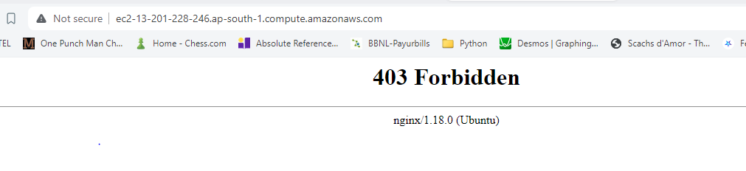

* Cd ~
* cd BloreHousePrediction/server
* ll
* tail -f /var/log/nginx/error.log

Note:- Error log

* sudo chown -R www-data:www-data /home/ubuntu/BloreHousePrediction/client
* sudo find /home/ubuntu/BloreHousePrediction/client -type d -exec chmod 755 {} \;
* sudo find /home/ubuntu/BloreHousePrediction/client -type f -exec chmod 644 {} \;
* sudo ln -s /etc/apparmor.d/usr.sbin.nginx /etc/apparmor.d/disable/
* sudo apparmor_parser -R /etc/apparmor.d/usr.sbin.nginx
* ls -l /home/ubuntu/BloreHousePrediction/client
* sudo chmod 755 /home /home/ubuntu /home/ubuntu/BloreHousePrediction /home/ubuntu/BloreHousePrediction/client
* sudo chown -R www-data:www-data /home/ubuntu/BloreHousePrediction/client
* sudo chmod -R 755 /home/ubuntu/BloreHousePrediction/client
* sudo systemctl restart nginx
* sudo chmod 755 /home /home/ubuntu /home/ubuntu/BloreHousePrediction /home/ubuntu/BloreHousePrediction/client
* sudo systemctl restart nginx
* Cd ~
* cd BloreHousePrediction/server
* ll
* sudo pip3 install -r /home/ubuntu/BloreHousePrediction/server/requirements.txt
* python3 /home/ubuntu/BloreHousePrediction/server/server.py
* python3 util.py
* python3 server.py
* Now reload the amazon host server in browser, you can see our home page of Bangalore House prediction

